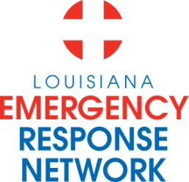

Louisiana Emergency Response Network
Board Meeting
June 13, 2012
2:00pm – 4:00pm
Location: Louisiana Emergency Response Network - Headquarters
14141 Airline Hwy, Suite One, Suite B Baton Rouge, LA 70817

AGENDA
1. Welcome and Introduction of New and Current LERN Board Members
2. Roll Call and Establish a Quorum
3. Approval of Agenda
4. Approval of Minutes of April 19, 2012 Board Meeting
5. Rapides Regional Medical Center Presentation
6. LERN Business:
- Executive Director Report/Legislative Update P. Hargrove
b. Ratification of Commission Members P. Hargrove
c. LINCCA P. Hargrove
- Board Resolution to adopt compliance policy
d. Financial Update P. Sullivan /C. Barr
e. Strategic Discussions:
e.1 Stroke Update K. Gaines, MD
e.2 Development of a System of R. Coscia, MD
State-designated Trauma Centers
e.3 Strategic Plan/FY 2012-2013 Priorities P. Hargrove
f. Ratify: EMS Registry Data Dictionary P. Hargrove

g. Code of Govt. Ethics Training/Reminder C. Cangelosi
h. Chairman’s Closing Remarks N. McSwain, MD
7. Public Comment
8. Adjournment

NEXT MEETING DATE Board Retreat August 17th & 18th, 2012
Omni Hotel New Orleans, La

